***Test 4 || 23 Dec 2024***

*Arjun Patel – FRN_006*

Que 1: Write a program to print factors of number in given range.

Eg. Range 10 to 15

10 = 1 , 2 , 5 , 10

11 = 1 , 11

12 = 1, 2, 3, 4, 6, 12

13 = 1, 13

14 = 1, 2, 7, 14

15 = 1, 3, 5, 15

*#include*<stdio.h>

void printFactor(int start, int end){

*for* (int i *=* start; i *<=* end; i*++*)

    {

        int num *=* i;

        printf("%d = ", num);

*for* (int j *=* 1; j *<=*num*/*2; j*++*)

        {

*if*(num *%* j*==*0) printf("%d, ", j);

        }

        printf("%d \n", num);

    }

}

int main(){

    int start, end;

    printf("Enter Start Value\n");

    scanf("%d", *&*start);

    printf("Enter Start Value\n");

    scanf("%d", *&*end);

    printFactor(start, end);

*return* 0;

}

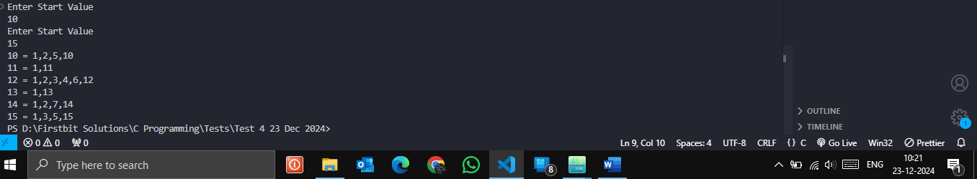

Que 2: Write a program to find power of any number.

Eg. 2^4 = 16.

*#include*<stdio.h>

int findPower(int base, int exponent){

    int pow *=* 1;

*while*(exponent*--*) pow *\*=* base;

*return* pow;

}

int main(){

    int base, exponent;

    printf("Enter the value of Base\n");

    scanf("%d", *&*base);

    printf("Enter the value of Exponent\n");

    scanf("%d", *&*exponent);

    printf("%d^%d = %d", base, exponent, findPower(base, exponent));

*return* 0;

}

